
Student Grading Management Sub-System
Nguyễn Hoàng Hiếu
HE163283 – DBI202 Slot 3
LECTURER: NGÔ TÙNG SƠN

1) DESCRIPTION OF THE DATABASE
- One student can join many groups and one group can have many students
- A subject can have many groups but a group can only participate in one subject
- A subject will have many assessments and each assessment can only be used for one subject
- A student studying only one major, one major will have many students
- Each student will be allowed to take up to 2 times the final exam and the 2nd test score (if any) will be counted as the final score.

Things that can be done with this database:
- Display test scores in ascending order of a class
- Calculate AVG score of a class
- Students can check their details scores of each subject
- Display student not enroll any class
- Check student pass or not pass
- Show curriculum of a student and status of each subject
- Calculate GPA of a student in one semester
- Find student has highest GPA of a major in 1 semester (coc vang)

2) ENTITY RELATIONSHIP DIAGRAM

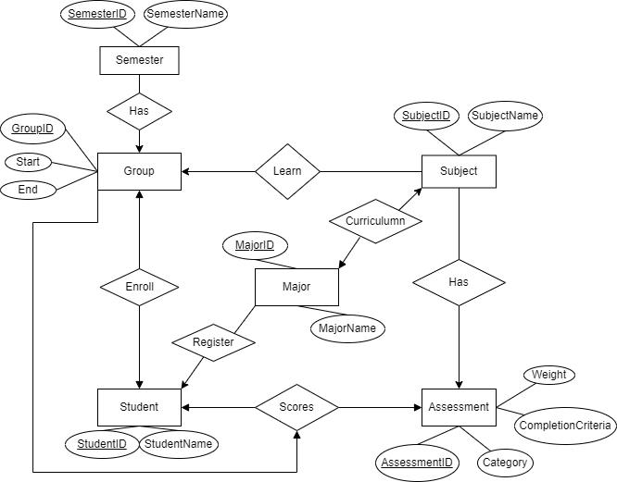
3) RELATIONAL SCHEMA
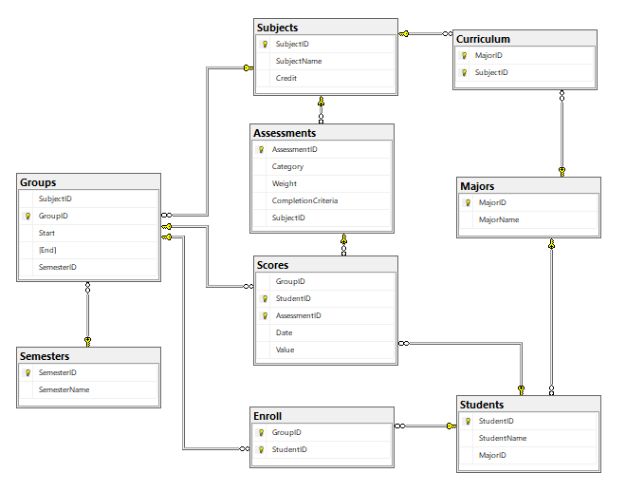

4) THE SET OF DATABASE STATEMENTS USED TO CREATE THE TABLES
Create table Subjects(
SubjectID nchar(6) PRIMARY KEY,
SubjectName nvarchar(50) not null,
Credit int
)

Create table Semesters(
SemesterID nvarchar(10) not null PRIMARY KEY,
SemesterName nvarchar(20) not null
)

Create table Majors(
MajorID nvarchar(5) primary key,
MajorName nvarchar (20) not null
)

Create table Students(
StudentID int not null PRIMARY KEY,
StudentName nvarchar(50) not null,
MajorID nvarchar(5) FOREIGN KEY REFERENCES [Majors](MajorID)
)

Create table Curriculum(
MajorID nvarchar(5) not null FOREIGN KEY REFERENCES [Majors](MajorID),
SubjectID nchar(6) not null FOREIGN KEY REFERENCES [Subjects](SubjectID),
CONSTRAINT pk_Curriculum PRIMARY KEY ([MajorID],[SubjectID])
)

Create table Assessments(
AssessmentID int not null PRIMARY KEY,
Category nvarchar(50) not null ,
[Type] nvarchar(50) not null CHECK ([type] in ('quiz','on-going','pratical exam','final exam')),
[Weight] float not null,
CompletionCriteria nvarchar,
SubjectID nchar(6) not null FOREIGN KEY REFERENCES [Subjects](SubjectID)
)

Create Table Scores(
StudentID int not null FOREIGN KEY REFERENCES [Students](StudentID),
AssessmentID int not null FOREIGN KEY REFERENCES [Assessments](AssessmentID),
[Date] date not null,
[Value] float,
CONSTRAINT pk_Scores PRIMARY KEY ([AssessmentID],[StudentID])
)

Create table Groups(
SubjectID nchar(6) not null FOREIGN KEY REFERENCES [Subjects](SubjectID),
GroupID nvarchar(20) not null PRIMARY KEY,
[Start] date not null,
[End] date not null,
SemesterID nvarchar(10) not null FOREIGN KEY REFERENCES [Semesters](SemesterID)
)

Create table Enroll(
GroupID nvarchar(20) not null FOREIGN KEY REFERENCES [Groups](GroupID),
StudentID int not null FOREIGN KEY REFERENCES [Students](StudentID),
CONSTRAINT pk_Group_Student PRIMARY KEY ([GroupID],[StudentID])
)

5) QUERY
-- Display test scores in ascending order of a class
-- Example: FE of SE1647_DBI202
Select s.StudentName,g.GroupID,a.Category,sc.Value
From Scores sc INNER JOIN Groups g ON sc.GroupID=g.GroupID
INNER JOIN Students s ON s.StudentID=sc.StudentID
INNER JOIN Assessments a ON a.AssessmentID=sc.AssessmentID
WHERE g.GroupID='SE1647_PRO192' and a.Category='FE'
Order by sc.Value

--Function calculate AVG of students
Create function Average
( @studentID int,
@groupID nvarchar(20)
)
Returns float
as
BEGIN
Declare @FE float
Declare @FEresist float
Declare @removedFE float
Set @removedFE=0
Declare @AVG float
Select @FEresist=sc.Value*a.Weight
From Scores sc INNER JOIN Groups g ON sc.GroupID=g.GroupID
INNER JOIN Students s ON s.StudentID=sc.StudentID
INNER JOIN Assessments a ON a.AssessmentID=sc.AssessmentID
WHere g.GroupID=@groupID and s.StudentID=@studentID and a.Category='FE(Resist)'

Select @FE=sc.Value*a.Weight
From Scores sc INNER JOIN Groups g ON sc.GroupID=g.GroupID
INNER JOIN Students s ON s.StudentID=sc.StudentID
INNER JOIN Assessments a ON a.AssessmentID=sc.AssessmentID
WHere g.GroupID=@groupID and s.StudentID=@studentID and a.Category='FE'

if @FEresist is not null
SET @removedFE=@FE

Select @AVG=SUM(Isnull(sc.Value,0)*a.[Weight])-@removedFE
From Scores sc INNER JOIN Groups g ON sc.GroupID=g.GroupID
INNER JOIN Students s ON s.StudentID=sc.StudentID
INNER JOIN Assessments a ON a.AssessmentID=sc.AssessmentID
WHERE g.GroupID=@groupID and s.StudentID=@studentID
Group by s.StudentName,g.GroupID

Return @AVG
END
-- Calculate AVG score of a class
Select s.StudentName,g.GroupID,
[dbo].Average(s.StudentID,g.GroupID) as AVG
From Groups g INNER JOIN Enroll e ON e.GroupID=g.GroupID
INNER JOIN Students s ON s.StudentID=e.StudentID
Where g.GroupID='SE1647_DBI202'

-- Students can check their details scores of each subject
Select s.StudentName, g.GroupID, g.SubjectID,a.Category,sc.Value
From Scores sc INNER JOIN Groups g ON sc.GroupID=g.GroupID
INNER JOIN Students s ON s.StudentID=sc.StudentID
INNER JOIN Assessments a ON a.AssessmentID=sc.AssessmentID
Where g.GroupID='SE1647_CSD201' and s.StudentID=1

--Display student not enroll any class
Select s.StudentName
From Students s LEFT JOIN Enroll e ON e.StudentID=s.StudentID
Where e.GroupID is null

--Check student pass or not pass
Create function CheckStatus
(
@ID int,
@groupID nvarchar(20)
)
Returns nvarchar(20)
AS
BEGIN
DECLARE @Status nvarchar(20)
DECLARE @AVG FLOAT;
DECLARE @FE FLOAT;
DECLARE @FEresist FLOAT;
DECLARE @Min FLOAT;
SET @Status = 'PASS';

Set @AVG=[dbo].Average(@ID,@groupID)
if @AVG<5
Set @Status = 'NOT PASS'

Select @FEresist=isnull(sc.Value,0)
From Scores sc INNER JOIN Groups g ON sc.GroupID=g.GroupID
INNER JOIN Students s ON s.StudentID=sc.StudentID
INNER JOIN Assessments a ON a.AssessmentID=sc.AssessmentID
WHere g.GroupID=@groupID and s.StudentID=@ID and a.Category='FE(Resist)'

Select @FE=isnull(sc.Value,0)
From Scores sc INNER JOIN Groups g ON sc.GroupID=g.GroupID
INNER JOIN Students s ON s.StudentID=sc.StudentID
INNER JOIN Assessments a ON a.AssessmentID=sc.AssessmentID
WHere g.GroupID=@groupID and s.StudentID=@ID and a.Category='FE'

if @FEresist <> 0
if @FEresist < 4 SET @Status='NOT PASS'

if @FE <4 or @FE=0
if @FEresist<4 or @FEresist =0
SET @Status='NOT PASS'

Select @MIN=MIN(isnull(sc.Value,0))
FROM Scores sc INNER JOIN Assessments a ON sc.AssessmentID=a.AssessmentID
WHERE GroupID=@groupID and StudentID=@ID and a.Category<>'FE' and a.Category<>'FE(Resist)'
IF @MIN=0
SET @Status='NOT PASS'

return @Status
END

--Show curriculum of a student and status of each subject
--Example: Student 5
Select s.StudentID,s.StudentName,g.GroupID,[dbo].CheckStatus(s.StudentID,e.GroupID) as Status
From Students s INNER JOIN Enroll e ON e.StudentID=s.StudentID
INNER JOIN Groups g ON g.GroupID=e.GroupID
Where s.StudentID=5

--Calculate GPA of a student in one semester
--Example: studentID = 1 and SemesterID = Su2022
Select s.StudentName, SUM([dbo].Average(s.StudentID,g.GroupID))/10*4 as GPA
From Groups g INNER JOIN Enroll e ON e.GroupID=g.GroupID
INNER JOIN Subjects su ON su.SubjectID=g.SubjectID
INNER JOIN Students s ON s.StudentID=e.StudentID
INNER JOIN Semesters se ON g.SemesterID=se.SemesterID
Where s.StudentID = 1 AND g.SemesterID='Su2022'
Group by s.StudentName

--Find student has highest GPA of a major in 1 semester (coc vang)
--Example: SE, Summer 2022
Select top 1 s.MajorID,s.StudentName, AVG([dbo].Average(s.StudentID,g.GroupID))/10*4 as GPA
From Groups g INNER JOIN Enroll e ON e.GroupID=g.GroupID
INNER JOIN Subjects su ON su.SubjectID=g.SubjectID
INNER JOIN Students s ON s.StudentID=e.StudentID
INNER JOIN Semesters se ON g.SemesterID=se.SemesterID
INNER JOIN Majors m ON s.MajorID=m.MajorID
Where s.MajorID='SE' and g.SemesterID='Su2022'
Group by s.StudentName,s.MajorID Order by GPA DESC
6) TRIGGER, PROCEDURE, VIEW
a, Trigger
--This trigger is used to prevent insert false weight of assesment, total weight of a subject = 1
Create Trigger Trigger_Weight ON Assessments
After INSERT,UPDATE
AS
DECLARE @Total float
Declare @Subject nchar(8)
Select @Subject= SubjectID from inserted
Select @Total=Sum(Weight) From Assessments Where SubjectID=@Subject
If @Total<>1
BEGin
print 'Total weight of subject must equal 1'
Rollback tran
END

b, Procedure
--PROCEDURE total GPA of a Student
Alter Procedure caculateGPA
@ID int
AS
BEGIN
Declare @totalCredit int
Declare @Major nvarchar(5)

Select @Major=MajorID from Students Where StudentID=@ID

Select @totalCredit=SUM(su.Credit)
FROM Majors m INNER JOIN Curriculum c ON m.MajorID=c.MajorID
INNER JOIN Subjects su ON su.SubjectID=c.SubjectID
Where c.MajorID=@Major

Select s.StudentID,s.StudentName, SUM(isnull([dbo].Average(s.StudentID,g.GroupID),0)*su.Credit)/@totalCredit*4/10 as GPA
From Groups g INNER JOIN Enroll e ON e.GroupID=g.GroupID
INNER JOIN Subjects su ON su.SubjectID=g.SubjectID
INNER JOIN Students s ON s.StudentID=e.StudentID
INNER JOIN Semesters se ON g.SemesterID=se.SemesterID
Where s.StudentID=@ID
Group by s.StudentID,s.StudentName
RETURN 0;
END

c, View
--Show list of passed student in 1 class
--Examle SE1647_DBI202
Create View SE1647DBIpass
AS Select s.StudentID,s.StudentName,MajorID
From Students s INNER JOIN Enroll e ON e.StudentID=s.StudentID
INNER JOIN Groups g ON g.GroupID=e.GroupID
Where g.GroupID='SE1647_DBI202' and [dbo].CheckStatus(s.StudentID,e.GroupID)='PASS'

